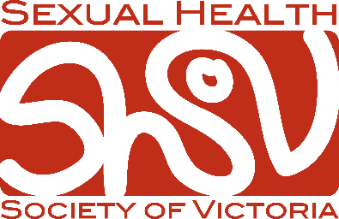 | SEXUAL HEALTH SOCIETY OF VICTORIA  2023 Educational Support Grants  Application Form

Educational Support Grant scheme
Each year, the SHSOV offers support grants to allow applications to undertake a professional educational activity in the field of sexual health or an allied discipline. These grants are intended to provide ‘top-up’ or support funding for those who may otherwise be unable to undertake the activities for which funding is sought.

Eligibility Requirements
Anyone living or working in Victoria with a professional or other interest in sexual health or a related field, such as family planning and reproductive health, may apply. SHSOV membership is not a prerequisite. Successful applicants from previous years may apply again, however preference will be given to new applicants.

Available funding
The maximum amount of funding available per applicant in 2023 is $500. The total amount awarded will be decided by the committee, and may be lower than requested.

How the funds may be used
- Assistance with costs (registration, accommodation, travel) to attend a conference or course
- Assistance with costs (accommodation, travel) to undertake a clinical attachment or training
- Assistance with costs to establish or complete a research project

Grant funds can be used to retrospectively to cover costs for activities already undertaken in 2023

Selection Criteria
Each application will be marked based on the following criteria:
- Aligns with the society’s goals: The extent to which the proposed activity aligns with the society’s commitment to multidisciplinary practice and knowledge exchange.
- Benefit to the applicant: The extent to which the grant will benefit the applicant in achieving their goals and in their career.
- Advancing the society’s profile: Capacity of the proposed activity to contribute to the growth/awareness of the SHSOV.
- Demonstrated need: Applicants have demonstrated a lack of alternative funding, or that grant fund will be used as a ‘top up’ when large amounts of funding are required.

Grant reporting
Applicants must agree to provide a 100-word statement on how the grant was used and how it was of benefit if successful. Successful applicants may also be asked to present their work at the SHSOV annual conference report-back seminar.

How to apply
To apply, please email the following documents to shsovictoria@gmail.com:
- Completed application form
- Curriculum Vitae
- Proof of abstract acceptance (if applicable)
Applications close 19th June 2023. Late and/or incomplete applications will not be considered, including those missing required documents.
Applicant details
Title
Name:
Phone number:
Email address:
Institution:
Qualifications:

Conference/course/program details
Applying for assistance for costs to: | □ Attend a conference or short course  □ Undertake a clinical attachment / training  □ Establish or complete a research project
Name and location:
Date:
Conference grants only
Have you submitted an abstract?
Has the abstract been accepted?
If applicable, what type of presentation will you be giving (e.g., oral presentation, poster presentation)?

Reasons for applying (Maximum 300 words)
Please provide your reasons for applying using the Selection Criteria 1-3 as a guide;
- Aligns with the SHSOV’s goals
- Benefit to the applicant
- Advancing the SHSOV’s profile

Abstract (conference grants only)
Please provide the presentation title and a copy of abstract

Budget
Please outline a brief budget for how the funds will be used.
If applicable, attach quotes or receipts for expenses (registration, travel, accommodation).
Other sources of funding
Declare other source(s) of funding and indicate how the remainder of costs will be covered, e.g., self-funded or through other grants. SHSOV grants are for a maximum of $500.

